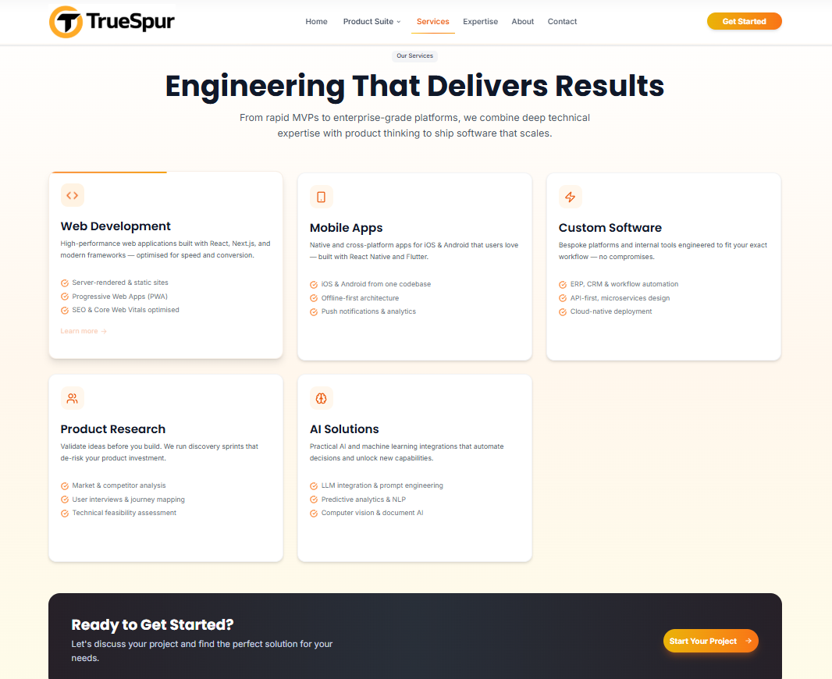

attached the output screen of the recent changes made. Review each component and overall section to ensure this looks professionally built by human and not random AI stuff. Below are my observation and changes I'd prefer -
1. Change card header
| Current | Better |
| ---------------- | ------------------------------ |
| Product Research | Product Discovery & Validation |
| Web Development | SaaS Product Development |
| Mobile Apps | Mobile Product Engineering |
| Custom Software | Enterprise Software Solutions |
| AI Solutions | Applied AI & Automation |
2. Add " how we help" kinda journey (Consider should this be added in this section, or we have another section in the website value realized - empowering innovation worldwide" which section is appropriate?
How We Help

1. Discover
Validate ideas before investing heavily.

2. Design
Create user experiences people actually adopt.

3. Build
Develop scalable web and mobile products.

4. Launch
Deploy, monitor, and optimize.

5. Scale
Add AI, automation, and enterprise capabilities.
Think of better human expert designed 5 stpes journey kinda experience.
3. Cards contains too much text
Nobody reads this:
High-performance web applications built with React, Next.js...
Visitors scan.
Instead:
SaaS Product Development
Build fast, scalable web platforms.
✓ MVPs & startup platforms
✓ Customer portals
✓ Enterprise SaaS applications
Similar do for other cards as well.

4. The cards feel visually heavy
The biggest design issue.
Every card has:
- Border
- Shadow
- Icon
- Text
- Bullet points
Everything has equal visual weight.
Premium websites create hierarchy.
Examples:
- Larger titles
- More whitespace
- Softer shadows
- Bigger icons
- Less content
Think:
Apple
Stripe
Linear
Vercel
Their secret is not fancy design.
It's restraint.

Product Discovery & Validation
Reduce risk before writing code.

UX & Product Design
Create experiences users love.

Product Engineering
Build secure web and mobile applications.

AI & Automation
Integrate intelligence into workflows.

Growth & Scale
Optimize infrastructure, performance, and operations.

5.Consider changing section headline and sub headline as follows
Instead of
Engineering That Delivers Results
From rapid MVPs to enterprise-grade platforms, we combine deep technical expertise with product thinking to ship software that scales.
Change to
Headline
How We Build Great Products
Subheadline
A proven blend of product strategy, design, engineering, and AI to turn ambitious ideas into scalable software.

